Table of Contents

Create test data for all tables suitable for generating reports 2

Design report and Create queries which will be used for generation of meaningful management reports. Present the report in HTML format. 7

Discuss briefly test methods you will employ to test and validate the database and brief reasons why you choose each test. 8

Document the database 14

Create a batch script to backup database & schedule it to run every 6 hours using windows task scheduler. Provide the script, along with the screen capture of Windows Task scheduler. 18

Provide a Restoration script in case of failure 22

# Create test data for all tables suitable for generating reports

City Table:

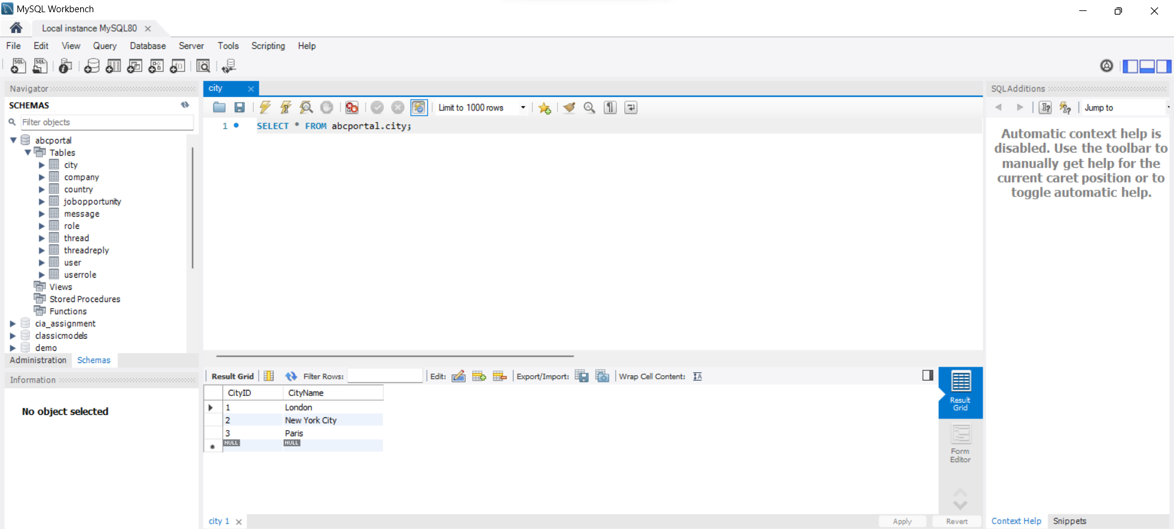

Company Table:

Country Table:

JobOpportunity Table:

Message Table:

Role Table:

Thread Table:

ThreadReply Table:

User Table:

UserRole Table:

# Design report and Create queries which will be used for generation of meaningful management reports. Present the report in HTML format.

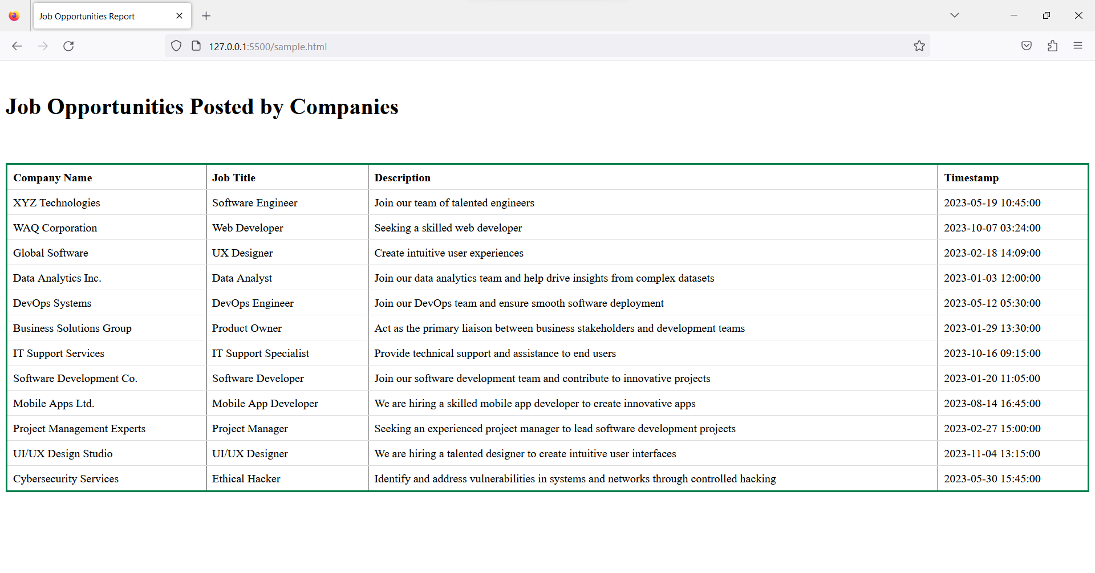Html Page:

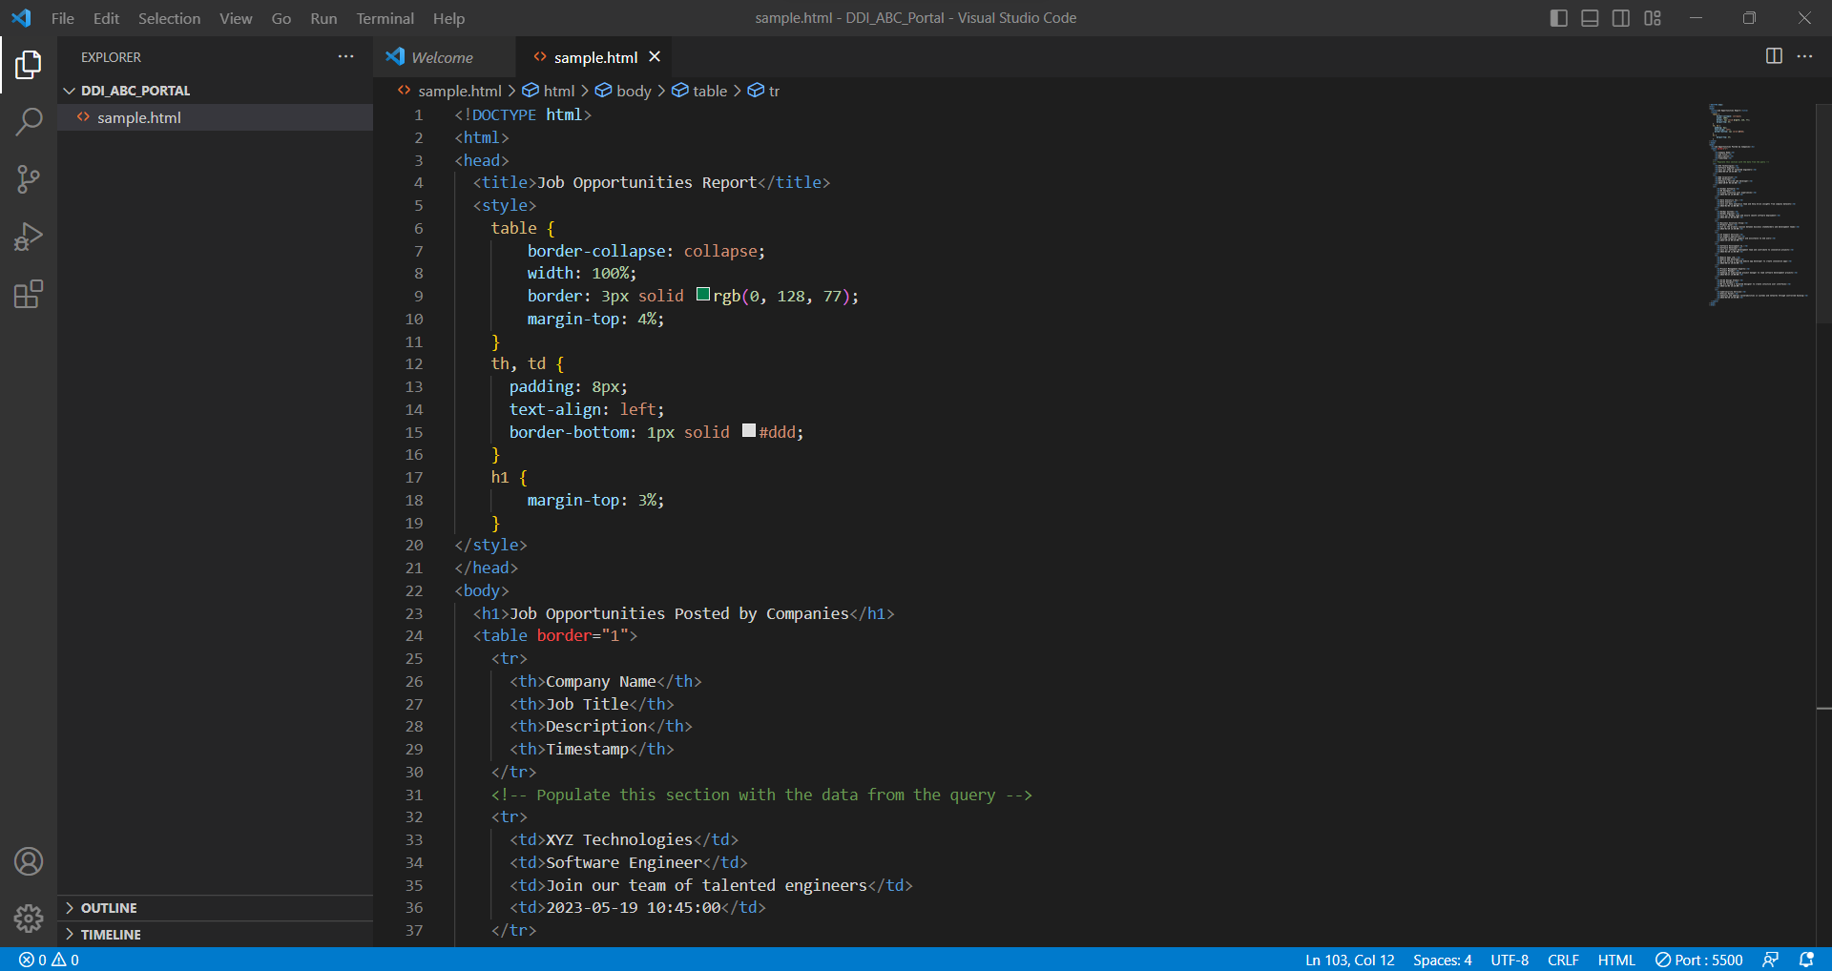

# Discuss briefly test methods you will employ to test and validate the database and brief reasons why you choose each test.

|  |  |  |  |  |  |
| --- | --- | --- | --- | --- | --- |
| Test Case ID | Test Case | Expectation | Actual | Result | Figure |
| DT-01 | Insert an invalid data into the table and try applying it | An error message would display | An error message appeared saying that it cannot be inserted | Pass | Fig 1, Fig2 |
| DT-02 | Insert data into the table without it’s Id | You cannot insert any data without it’s Id | A system error will occur since it’s not auto generated | Pass | Fig 3, Fig 4 |
| DT-03 | Insert wrong data type into the table | Data will not be inserted, and an error message will appear | Data is not inserted, and an error message will appear | Pass | Fig 5, Fig 6 |
| DT-04 | Check invalid referential integrity when new data is inserted | Error message will be displayed | Error message displayed | Pass | Fig 7, Fig 8, Fig 9 |
| DT-05 | Insert more than 20 characters into the “Company Name” column in the “company” table | Data will not be inserted into the table | A message saying that the data cannot be inserted into the table because the data range for the “Company Name” column is only 32 | Pass | Fig 10, Fig 11, Fig 12 |
| DT-06 | Inserting duplicate values into a column with a unique constraint | The database should reject the operation and raise an error | The database rejects the operation and raises an error | Pass | Fig 13, Fig 14, Fig 15 |
| DT-07 | Delete a record in the specialist table | Record should get deleted | Record is successfully deleted | Pass | Fig 16, Fig 17 |

Fig 1

Fig 2

Fig 3

Fig 4

Fig 5

Fig 6

Fig 7

Fig 8

Fig 9

Fig 10

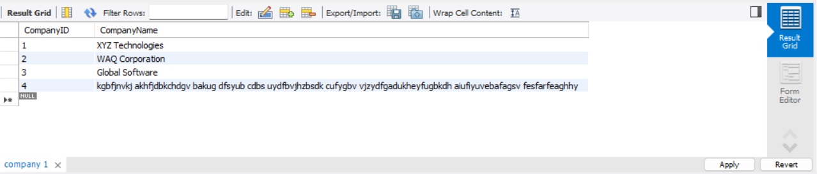

Fig 11

Fig 12

Fig 13

Fig 14

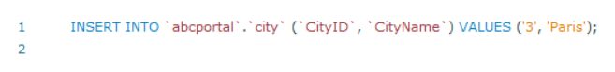

Fig 15

Fig 16

Fig 17

# Document the database

Objectives:

The ABC Job Portal database's goals include storing and managing user data, roles, messages, threads, job opportunities, companies, countries, and cities. It intends to offer role-based access management, enable message and conversation functions, facilitate effective user data search and retrieval, and provide data for insightful reporting and analysis.

EER Diagram:

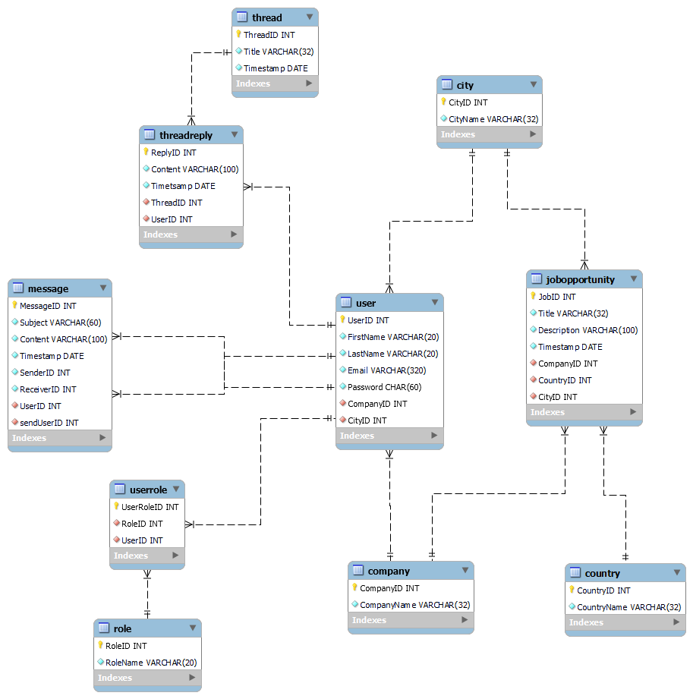

Data Dictionary:

|  |  |  |  |
| --- | --- | --- | --- |
| Table Name | Field Name | Field Type | Description |
| User | UserID | Int | Represents portal users with a unique ID |
|  | FristName | Varchar(20) | First name of the user |
|  | LastName | Varchar(20) | Last name of the user |
|  | Email | Varchar(320) | Email address of the user |
|  | Password | Char(60) | User’s password for the login authentication |
|  | CompanyID | Int | Foreign key referencing the company table |
|  | CityID | Int | Foreign key referencing the city table |
| Role | RoleID | Int | Represents different roles with a unique ID |
|  | RoleName | Varchar(20) | Name of the role |
| UserRole | UserRoleID | Int | Primary key |
|  | RoleID | Int | Foreign key referencing the Role table |
|  | UserID | Int | Foreign key referencing the User table |
| Message | MessageID | Int | Unique ID for each message |
|  | Subject | Varchar(60) | Title of the message |
|  | Content | Varchar(100) | Description of the message |
|  | Timestamp | Date | Timestamp of when the message was sent |
|  | SenderID | Int | Foreign key referencing the User table (sender) |
|  | ReceiverID | Int | Foreign key referencing the User table (receiver) |
|  | UserID | Int | Foreign key referencing the User table |
| City | CityID | Int | Unique ID for each city |
|  | CityName | Varchar(32) | Name of the city |
| Company | CompanyID | Int | Unique ID for each company |
|  | CompanyName | Varchar(32) | Name of the company |
| Country | CountryID | Int | Unique ID for each country |
|  | COuntryName | Varchar(32) | Name of the country |
| JobOpportunity | JobID | Int | Unique ID for each job opportunity |
|  | Title | Varchar(32) | Title of the job opportunity |
|  | Description | Varchar(100) | Description of the job opportunity |
|  | Timestamp | Date | Timestamp of when the job opportunity was posted |
|  | CompanyID | Int | Foreign key referencing the Company table |
|  | CountryID | Int | Foreign key referencing the Country table |
|  | CityID | Int | Foreign key referencing the City table |
| Thread | ThreadID | Int | Unique ID for each thread |
|  | Title | Varchar(32) | Title of the thread |
|  | Timestamp | Date | Timestamp of when the thread was created |
| ThreadReply | ReplyID | Int | Unique ID for each thread reply |
|  | Content | Varchar(100) | Content of the thread reply |
|  | Timestamp | Date | Timestamp of when the reply was posted |
|  | ThreadID | Int | Foreign key referencing the Thread table |
|  | UserID | Int | Foreign key referencing the User table |

# Create a batch script to backup database & schedule it to run every 6 hours using windows task scheduler. Provide the script, along with the screen capture of Windows Task scheduler.

Batch File:

Window Task Scheduler:

# Provide a Restoration script in case of failure

Batch File:

